PRIVACY POLICY
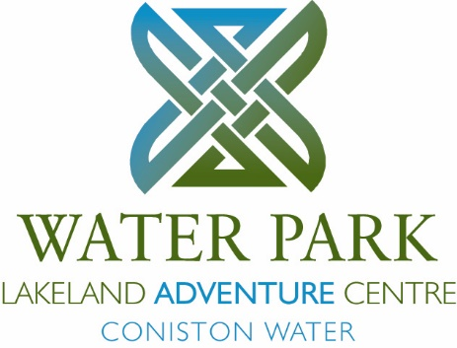
WATER PARK LIMITED

This notice explains how and why we collect information about you, your child or children you are bringing to Water Park and what we do with it.
The information we collect is personal data and under the General Data Protection Regulation (GDPR) in force from 25 May 2018 we are obliged to hold this data securely protected against unauthorised or unlawful processing, accidental loss, destruction or damage and only for so long as is necessary in connection with our relationship with you.
We at Water Park Limited are a Data Controller for the purposes of the data protection laws in force in this country.
We collect personal information or data which you or your child’s school provide to us such as:

Names, | Photographs
Addresses | Children’s likes and dislikes
Contact details | Nationality
Family relationships | Ethnicity
Medical information | Language
Gender | Bedroom & group lists
Special educational needs
We hold this information in paper and electronic form and it is kept securely in locked filing cabinets or on computer databases with restricted access.
We hold the information to enable us properly to carry out our contractual obligations to support you or your child’s experience of and learning and development at Water Park and to provide appropriate pastoral care,
We do not share the information we hold with anyone else apart from where it is necessary for financial purposes and the enforcement of your contract with us. Personal data may be shared with companies within the Eric Wright Group of companies who provide services to Water Park and are owned by the Eric Wright Charitable Trust as is Water Park
We may also be required by law to pass some of the information to government departments, local authorities, the Department for Education, Ofsted and law enforcement agencies.
We hold the information for specified periods after you, your child or the children you are bringing to Water Park leave us, after which it is deleted from our databases or shredded if in paper form.

The specified periods are:

Medical forms - 6 months

Accident forms & associated medical form – until the child’s 22nd birthday

Photographs – deleted immediately after visit if copied by school. OR, held for a maximum of two weeks if Water Park are awaiting a memory stick from school for transfer of pictures after which photos are deleted. With the parents express written permission we may use photographs for publicity material.

All other information – 12 months

You have the right to request details of the information we are holding.
To ask for details, please make a request in writing to Garry Dobson, Head of Centre, Water Park, High Nibthwaite, Ulverston, Cumbria LA12 8DQ by post or email at office@waterparkadventure.co.uk and provide details of the address to which the copies and details should be sent. If any of the information is inaccurate you may ask us to amend or delete it.
If you are unhappy with the way we hold your information or deal with your request to access it you have the right to lodge a complaint with the Information Commissioner who is the supervisory authority for the United Kingdom and may be contacted at https://ico.org.uk/concerns or by telephone on [0303 123 1113 ]

PTO

MEDICAL & CONSENT FORM (All participants - Please use capital letters)

Participant’s Full Name:………………………………….. School/Organisation:………………………………………

Date of Birth: (Under 18’s)………………………………..Dates of Visit:. From…………….... To………………….

Parent/Guardian Name (Under 18’s)…………………………… Please tick box if you are a member of a staff

Address:……………………………………………………………………………………………………………………

………………………………………………… Post Code:………………………………………………

Tel. No: (day)…………………………………………… (eve)…………………………………………………….

Emergency Contact Name:…………………………….. Emergency Contact No:………………………………..

Doctor’s Name:…………………………………………. Doctor’s Tel No:………………………………………..

Doctors Address:…………………………………………………………………………………………………………...

Personal Information – Please tick relevant boxes. Please complete an Additional Information Form if you /your child has additional/special needs.
Do you / your child have any special dietary requirements? Yes no
Please give details (e.g. vegetarian, halal, gluten free, etc.)
Please use additional information form for further information

Do you / your child have a medical condition of which we should be aware of? Yes no
Please give details (e.g. Asthma, diabetes, epilepsy, sensory impairment etc.)

Are you / your child currently receiving medical treatment or medication? Yes no
If yes please give details

Have you / your child had surgery or an injury in the past year? Yes no If yes, please give details.

Are you / they fully recovered? yes no
Do you / your child have an allergy? yes no If yes, please give details of type, of severity and medication:

Have you / your child had a Tetanus injection in the past 5 years? Yes no

Is there any other information we need to know (i.e. learning difficulties, emotional issues /trauma, special circumstances, not water confident)?

I understand that I am /my child is to attend an outdoor activities course and I agree to / him/ her taking part. To the best of my knowledge, I am / my child is in good health. In case of accident or illness whilst away from home. I consent to any emergency medical treatment which is deemed necessary.

Signed:………………………………………………. Date:………………………

I do/do not give permission for my own/my childs photograph to be used for publicity material.

Signed:………………………………………………. Date:………………………

If the participant is under 18, this must be signed by a parent / guardian
PTO

